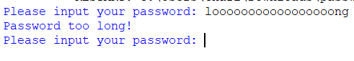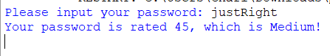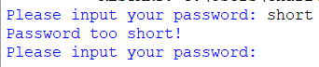
Regarding the tests, none of them “failed” per say. I had a few syntax errors that made the program crash a few times, but they were simple fixes like forgetting to put an equal to (==) and putting an equals (=) instead. That was the worst of the errors I encountered.
Some differences from the pseudocode and flow chart were made. I was originally going to use subroutines so that I could re use the code if needed, similarly to how I have in other mocks. However, this specific program didn’t have much code that could be re used. Most of it was used once and never needed to be reused, making using subroutines redundant. Despite this, I believe it met the testing requirements, since the program functions properly, doesn’t crash (that I’ve seen), no logic errors (that I’ve seen), and clear directions on what to do when something is invalid.

